TUGAS FORMATIF 2
PEMROGRAMAN MOBILE LANJUT



Disusun oleh:
Henny Sweet Zai 2022320055

PROGRAM STUDI SISTEM INFORMASI
FAKULTAS INFORMATIKA
UNIVERSITAS BINA INSANI
BEKASI
2024
OUTPUT
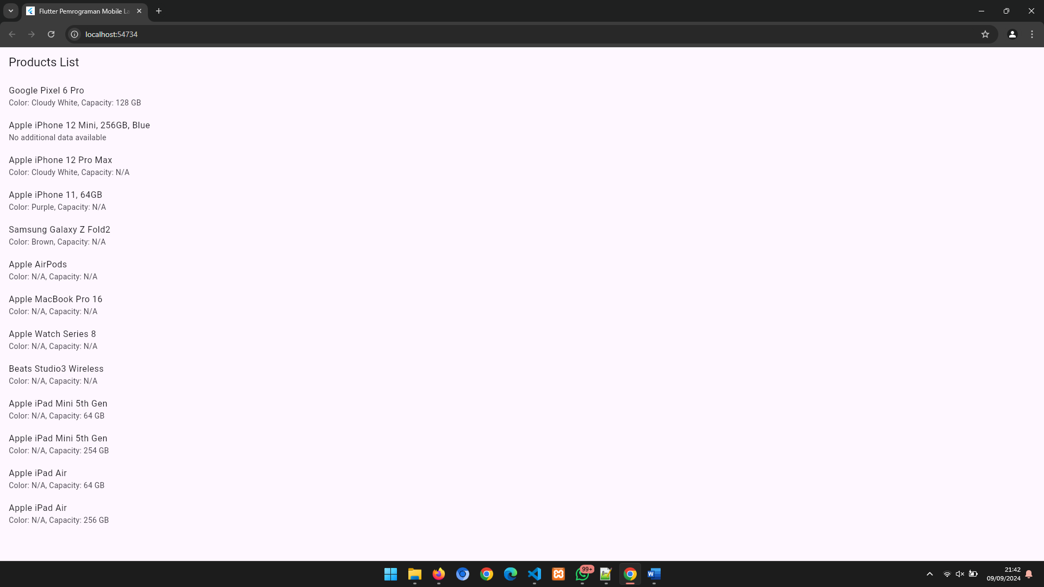

main.dart
import 'package:flutter/material.dart';
import 'models/data_model.dart';

void main() {
runApp(const MyApp());
}

class MyApp extends StatelessWidget {
const MyApp({super.key});

@override
Widget build(BuildContext context) {
return MaterialApp(
debugShowCheckedModeBanner: false,
title: 'Flutter Pemrograman Mobile Lanjut',
theme: ThemeData(
colorScheme: ColorScheme.fromSeed(seedColor: Colors.deepPurple),
useMaterial3: true,
),
home: const FormatifHenny(),
);
}
}

data_model.dart
// ignore_for_file: library_private_types_in_public_api

import 'package:flutter/material.dart';
import '../services/services.dart';

class FormatifHenny extends StatefulWidget {
const FormatifHenny({super.key});

@override
_FormatifHennyState createState() => _FormatifHennyState();
}

class _FormatifHennyState extends State<FormatifHenny> {
late Future<List<Product>> futureProducts;

@override
void initState() {
super.initState();
futureProducts = ProductService().fetchProducts(); // Memanggil fetch data
}

@override
Widget build(BuildContext context) {
return Scaffold(
appBar: AppBar(
title: const Text('Products List'),
),
body: FutureBuilder<List<Product>>(
future: futureProducts,
builder: (context, snapshot) {
if (snapshot.connectionState == ConnectionState.waiting) {
return const Center(child: CircularProgressIndicator());
} else if (snapshot.hasError) {
return Center(child: Text('Error: ${snapshot.error}'));
} else if (snapshot.hasData) {
List<Product> products = snapshot.data!;

return ListView.builder(
itemCount: products.length,
itemBuilder: (context, index) {
final product = products[index];
final data = product.data;

return ListTile(
title: Text(product.name),
subtitle: data != null
? Text(
'Color: ${data['color'] ?? 'N/A'}, Capacity: ${data['capacity'] ?? data['Capacity'] ?? 'N/A'}')
: const Text('No additional data available'),
);
},
);
} else {
return const Center(child: Text('No products found.'));
}
},
),
);
}
}

services.dart
// ignore_for_file: depend_on_referenced_packages

import 'dart:convert';
import 'package:http/http.dart' as http;

class Product {
final String id;
final String name;
final Map<String, dynamic>? data;

Product({required this.id, required this.name, this.data});

// Factory method untuk mem-parsing JSON
factory Product.fromJson(Map<String, dynamic> json) {
return Product(
id: json['id'],
name: json['name'],
data: json['data'],
);
}
}

class ProductService {
// Ganti dengan URL API-mu
final String apiUrl = 'https://api.restful-api.dev/objects';

// Metode untuk fetch data dari API
Future<List<Product>> fetchProducts() async {
final response = await http.get(Uri.parse(apiUrl));

if (response.statusCode == 200) {
List<dynamic> body = jsonDecode(response.body);
List<Product> products =
body.map((dynamic item) => Product.fromJson(item)).toList();
return products;
} else {
throw Exception('Failed to load products');
}
}
}

pubspec.yaml
name: pmlbiu
description: "A new Flutter project."
# The following line prevents the package from being accidentally published to
# pub.dev using `flutter pub publish`. This is preferred for private packages.
publish_to: "none" # Remove this line if you wish to publish to pub.dev

# The following defines the version and build number for your application.
# A version number is three numbers separated by dots, like 1.2.43
# followed by an optional build number separated by a +.
# Both the version and the builder number may be overridden in flutter
# build by specifying --build-name and --build-number, respectively.
# In Android, build-name is used as versionName while build-number used as versionCode.
# Read more about Android versioning at https://developer.android.com/studio/publish/versioning
# In iOS, build-name is used as CFBundleShortVersionString while build-number is used as CFBundleVersion.
# Read more about iOS versioning at
# https://developer.apple.com/library/archive/documentation/General/Reference/InfoPlistKeyReference/Articles/CoreFoundationKeys.html
# In Windows, build-name is used as the major, minor, and patch parts
# of the product and file versions while build-number is used as the build suffix.
version: 1.0.0+1

environment:
sdk: ">=3.2.3 <4.0.0"

# Dependencies specify other packages that your package needs in order to work.
# To automatically upgrade your package dependencies to the latest versions
# consider running `flutter pub upgrade --major-versions`. Alternatively,
# dependencies can be manually updated by changing the version numbers below to
# the latest version available on pub.dev. To see which dependencies have newer
# versions available, run `flutter pub outdated`.
dependencies:
flutter:
sdk: flutter

# The following adds the Cupertino Icons font to your application.
# Use with the CupertinoIcons class for iOS style icons.
cupertino_icons: ^1.0.2

dev_dependencies:
flutter_test:
sdk: flutter
http: ^0.13.4

# The "flutter_lints" package below contains a set of recommended lints to
# encourage good coding practices. The lint set provided by the package is
# activated in the `analysis_options.yaml` file located at the root of your
# package. See that file for information about deactivating specific lint
# rules and activating additional ones.
flutter_lints: ^2.0.0

# For information on the generic Dart part of this file, see the
# following page: https://dart.dev/tools/pub/pubspec

# The following section is specific to Flutter packages.
flutter:
# The following line ensures that the Material Icons font is
# included with your application, so that you can use the icons in
# the material Icons class.
uses-material-design: true

# To add assets to your application, add an assets section, like this:
# assets:
# - images/a_dot_burr.jpeg
# - images/a_dot_ham.jpeg

# An image asset can refer to one or more resolution-specific "variants", see
# https://flutter.dev/assets-and-images/#resolution-aware

# For details regarding adding assets from package dependencies, see
# https://flutter.dev/assets-and-images/#from-packages

# To add custom fonts to your application, add a fonts section here,
# in this "flutter" section. Each entry in this list should have a
# "family" key with the font family name, and a "fonts" key with a
# list giving the asset and other descriptors for the font. For
# example:
# fonts:
# - family: Schyler
# fonts:
# - asset: fonts/Schyler-Regular.ttf
# - asset: fonts/Schyler-Italic.ttf
# style: italic
# - family: Trajan Pro
# fonts:
# - asset: fonts/TrajanPro.ttf
# - asset: fonts/TrajanPro_Bold.ttf
# weight: 700
#
# For details regarding fonts from package dependencies,
# see https://flutter.dev/custom-fonts/#from-packages

